
Lab Report 10
Data Communication & Computer Networks


Submitted To:
Engineer Shehzad Malik
Submitted By:
Sumama Rahim
F24BSCS039
BS CS (F24-A-Morning)
Date: 12/17/2025
LAB REPORT – 10
Cisco Packet Tracer – VLAN

Problem:
Investigating VLAN
Solution:

Task 1: Checking the interface status
Goto CLI (on switch)
type enable > show interfaces status

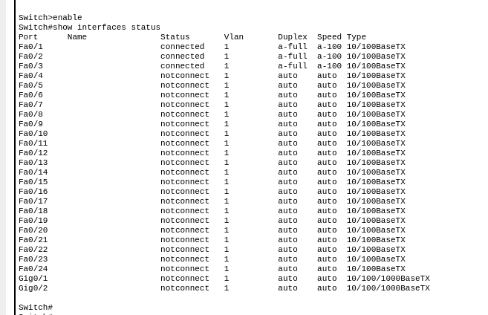
where 24 are FastEthernet and 2 are GigaEthernet interfaces so total are 26 by default. And by default all ports are member of VLAN 1. But we can change it. And by default there are 5 d/f vlans

Task 2: Checking for VLANs

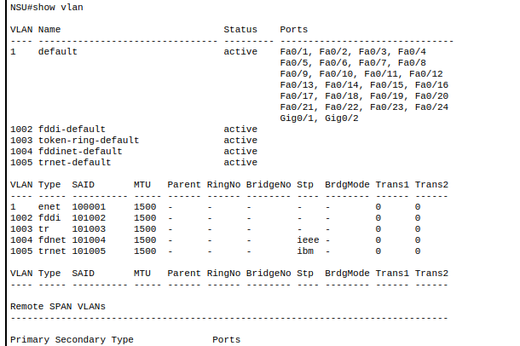
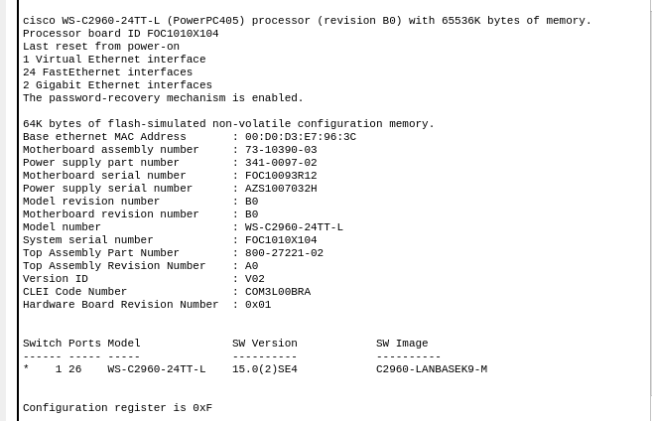
type show version in enable mode:

Task 3: Let’s check for VLAN brief

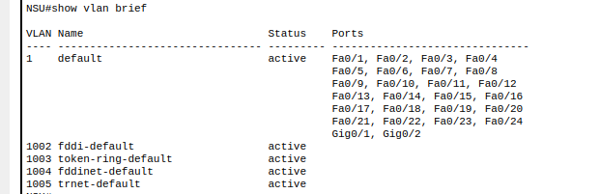

By default no MAC address is in table because we didn’t attached any PC or Printer etc.

The End

